DBS211 – Final Project

Group 4 Members:

**Luca Novello || Philip Graham || Jaseem Villan Thenkodath**

# Milestone 1 – Project Idea and Proposal

## Introduction:

In the digital age of music, enthusiasts are increasingly relying on online platforms to organize and enjoy their music collections. This project involves designing a database for a music library management system that allows users to manage their music collections using artist, album, metadata, and user-created playlists. The team chose this topic as we all share an appreciation and interest for music.

## Problem Statement:

The need for this database arises from the requirement to efficiently organize and manage large music collections, providing users with an easy way to access, categorize, and personalize their music libraries. Without a well-structured database, handling music metadata and user preferences would be cumbersome, leading to a suboptimal user experience.

## Solution:

Our team will build a relational database that supports our music library application. The database will store comprehensive information about songs, artists, albums, and user-created playlists. It will facilitate efficient data retrieval for music management, playlist creation, and personalized music recommendations.

## Requirements:

* User Login/Registration
* Profile Management
* Song Metadata Management (ratings, genre…)
* Artist Information
* Album Information
* User-Created Playlists
* Data Reports

Milestone 2 – Database Design

## ERD (Entity Relationship Diagram):

|  |  |  |
| --- | --- | --- |
| USERS  * + **UserID (Primary Key)**   + Username   + Password   + Email   + ProfilePicture | ARTISTS  * + **ArtistID (Primary Key)**   + ArtistName   + Genre   + Country | ALBUMS  * + **AlbumID (Primary Key)**   + AlbumName   + ReleaseDate   + ArtistID (Foreign Key) |
| SONGS  * + **SongID (Primary Key)**   + SongName   + Duration   + AlbumID (Foreign Key)   + ArtistID (Foreign Key)   + Genre | PLAYLISTS  * + **PlaylistID (Primary Key)**   + PlaylistName   + UserID (Foreign Key) | PLAYLISTSONGS  * + **PlaylistID (Primary Key, Foreign Key)**   + **SongID (Primary Key, Foreign Key)** |

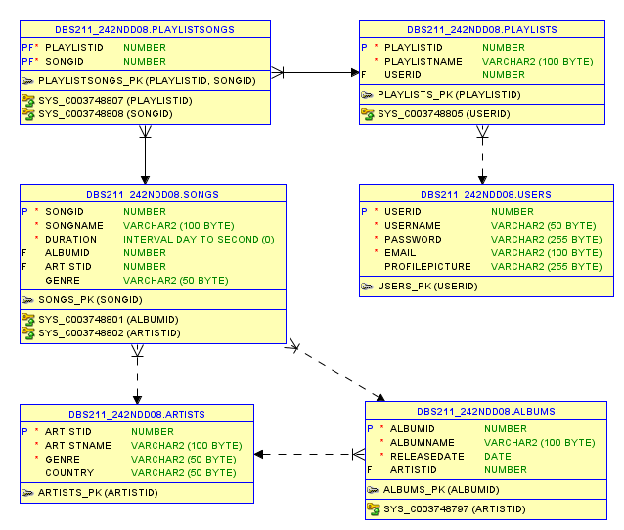

## Data Dictionary:

|  |  |  |  |  |  |  |  |  |  |
| --- | --- | --- | --- | --- | --- | --- | --- | --- | --- |
| **Table** | **Column** | **Data Type** | **Size** | **Default** | **PK/FK** | **Required** | **Range** | **Sample Data** | **Notes** |
| Users | UserID | INT | 11 |  | PK | Y | 1-999999 | 1 | Auto numbered identity |
| Users | Username | VARCHAR | 50 |  |  | Y |  | johndoe |  |
| Users | Password | VARCHAR | 255 |  |  | Y |  | password123 |  |
| Users | Email | VARCHAR | 100 |  |  | Y |  | johndoe@mail.com |  |
| Users | ProfilePicture | VARCHAR | 255 |  |  | N |  | profile.jpg |  |
| Artists | ArtistID | INT | 11 |  | PK | Y | 1-999999 | 1 | Auto numbered identity |
| Artists | ArtistName | VARCHAR | 100 |  |  | Y |  | The Beatles |  |
| Artists | Genre | VARCHAR | 50 |  |  | Y |  | Rock |  |
| Artists | Country | VARCHAR | 50 |  |  | N |  | UK |  |
| Albums | AlbumID | INT | 11 |  | PK | Y | 1-999999 | 1 | Auto numbered identity |
| Albums | AlbumName | VARCHAR | 100 |  |  | Y |  | Abbey Road |  |
| Albums | ReleaseDate | DATE |  |  |  | Y |  | 1969-09-26 |  |
| Albums | ArtistID | INT | 11 |  | FK | Y | 1-999999 | 1 | References Artists(ArtistID) |
| Songs | SongID | INT | 11 |  | PK | Y | 1-999999 | 1 | Auto numbered identity |
| Songs | SongName | VARCHAR | 100 |  |  | Y |  | Come Together |  |
| Songs | Duration | TIME |  |  |  | Y |  | 0:04:20 |  |
| Songs | AlbumID | INT | 11 |  | FK | Y | 1-999999 | 1 | References Albums(AlbumID) |
| Songs | ArtistID | INT | 11 |  | FK | Y | 1-999999 | 1 | References Artists(ArtistID) |
| Songs | Genre | VARCHAR | 50 |  |  | N |  | Rock |  |
| Playlists | PlaylistID | INT | 11 |  | PK | Y | 1-999999 | 1 | Auto numbered identity |
| Playlists | PlaylistName | VARCHAR | 100 |  |  | Y |  | My Favorites |  |
| Playlists | UserID | INT | 11 |  | FK | Y | 1-999999 | 1 | References Users(UserID) |
| PlaylistSongs | PlaylistID | INT | 11 |  | PK, FK | Y | 1-999999 | 1 | Composite PK, References PlaylistID |
| PlaylistSongs | SongID | INT | 11 |  | PK, FK | Y | 1-999999 | 1 | Composite PK, References SongID |